**By Sachin Ray (SuperSet ID: 6364957)**

**Exercise 1: Implementing the Singleton Pattern**

**Scenario:**

You need to ensure that a logging utility class in your application has only one instance throughout the application lifecycle to ensure consistent logging.

**Steps:**

1. **Create a New Java Project:**
   * Create a new Java project named **SingletonPatternExample**.
2. **Define a Singleton Class:**
   * Create a class named Logger that has a private static instance of itself.
   * Ensure the constructor of Logger is private.
   * Provide a public static method to get the instance of the Logger class.
3. **Implement the Singleton Pattern:**
   * Write code to ensure that the Logger class follows the Singleton design pattern.
4. **Test the Singleton Implementation:**
   * Create a test class to verify that only one instance of Logger is created and used across the application.

**SOLUTION :**Logger.cs Code :

using System;

using System.IO;

namespace SingletonPatternExample

{

public sealed class Logger

{

private static Logger? _instance = null;

private static readonly object _lock = new object();

private Logger()

{

InitializeLogger();

}

public static Logger GetInstance()

{

if (_instance == null)

{

lock (_lock)

{

if (_instance == null)

{

_instance = new Logger();

}

}

}

return _instance;

}

private void InitializeLogger()

{

Console.WriteLine("Logger initialized successfully!");

}

public void LogInfo(string message)

{

string logEntry = $"[INFO] {DateTime.Now:yyyy-MM-dd HH:mm:ss} - {message}";

Console.WriteLine(logEntry);

WriteToFile(logEntry);

}

public void LogError(string message)

{

string logEntry = $"[ERROR] {DateTime.Now:yyyy-MM-dd HH:mm:ss} - {message}";

Console.WriteLine(logEntry);

WriteToFile(logEntry);

}

public void LogWarning(string message)

{

string logEntry = $"[WARNING] {DateTime.Now:yyyy-MM-dd HH:mm:ss} - {message}";

Console.WriteLine(logEntry);

WriteToFile(logEntry);

}

private void WriteToFile(string logEntry)

{

try

{

string logFile = "application.log";

File.AppendAllText(logFile, logEntry + Environment.NewLine);

}

catch (Exception ex)

{

Console.WriteLine($"Failed to write to log file: {ex.Message}");

}

}

public override int GetHashCode()

{

return base.GetHashCode();

}

}

}

SingletonTest.cs Code :

using System;

using System.Threading;

namespace SingletonPatternExample

{

public class SingletonTest

{

public static void TestSingletonPattern()

{

Console.WriteLine("=== Testing Singleton Pattern ===\n");

Logger logger1 = Logger.GetInstance();

Logger logger2 = Logger.GetInstance();

Logger logger3 = Logger.GetInstance();

Console.WriteLine("Testing instance equality:");

Console.WriteLine($"logger1 == logger2: {ReferenceEquals(logger1, logger2)}");

Console.WriteLine($"logger2 == logger3: {ReferenceEquals(logger2, logger3)}");

Console.WriteLine($"logger1 == logger3: {ReferenceEquals(logger1, logger3)}");

Console.WriteLine($"\nInstance Hash Codes:");

Console.WriteLine($"logger1 HashCode: {logger1.GetHashCode()}");

Console.WriteLine($"logger2 HashCode: {logger2.GetHashCode()}");

Console.WriteLine($"logger3 HashCode: {logger3.GetHashCode()}");

Console.WriteLine("\n=== Testing Logger Functionality ===");

logger1.LogInfo("Application started successfully");

logger2.LogWarning("This is a warning message from logger2");

logger3.LogError("This is an error message from logger3");

logger1.LogInfo("All loggers are actually the same instance");

Console.WriteLine("\n=== Testing Thread Safety ===");

Thread[] threads = new Thread[5];

for (int i = 0; i < 5; i++)

{

int threadId = i;

threads[i] = new Thread(() =>

{

Logger threadLogger = Logger.GetInstance();

threadLogger.LogInfo($"Message from Thread {threadId} - HashCode: {threadLogger.GetHashCode()}");

});

}

foreach (Thread thread in threads)

{

thread.Start();

}

foreach (Thread thread in threads)

{

thread.Join();

}

Console.WriteLine("\nSingleton Pattern test completed successfully!");

}

}

}

Main file:  
Program.cs Code :

using System;

namespace SingletonPatternExample

{

class Program

{

static void Main(string[] args)

{

Console.WriteLine("Singleton Pattern Example in C#");

Console.WriteLine("================================\n");

SingletonTest.TestSingletonPattern();

Console.WriteLine("\nPress any key to exit...");

Console.ReadKey();

}

}

}

**OUTPUT** :

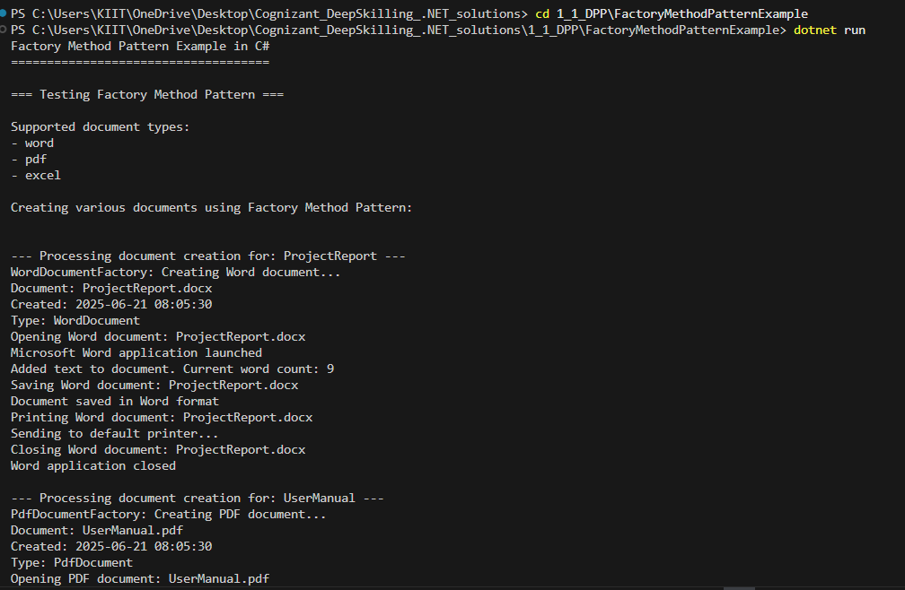

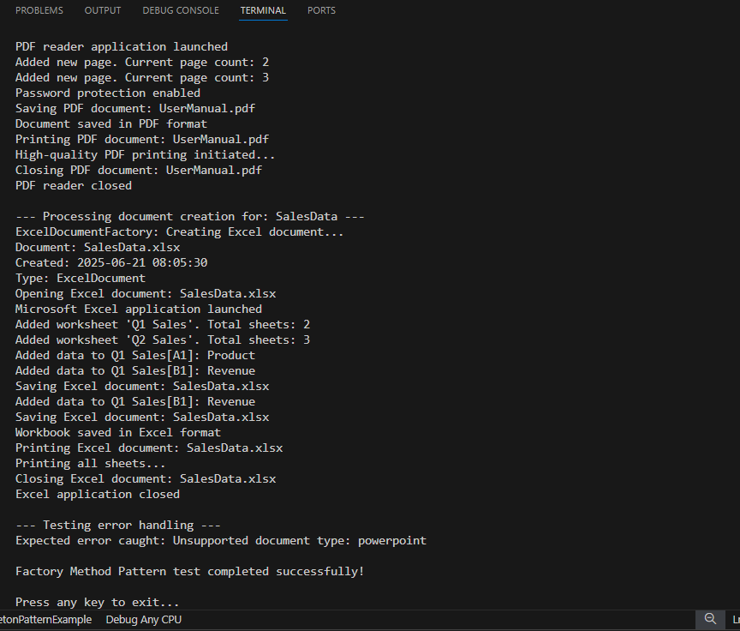

**Exercise 2: Implementing the Factory Method Pattern**

**Scenario:**

You are developing a document management system that needs to create different types of documents (e.g., Word, PDF, Excel). Use the Factory Method Pattern to achieve this.

**Steps:**

1. **Create a New Java Project:**
   * Create a new Java project named **FactoryMethodPatternExample**.
2. **Define Document Classes:**
   * Create interfaces or abstract classes for different document types such as **WordDocument**, **PdfDocument**, and **ExcelDocument**.
3. **Create Concrete Document Classes:**
   * Implement concrete classes for each document type that implements or extends the above interfaces or abstract classes.
4. **Implement the Factory Method:**
   * Create an abstract class **DocumentFactory** with a method **createDocument()**.
   * Create concrete factory classes for each document type that extends DocumentFactory and implements the **createDocument()** method.
5. **Test the Factory Method Implementation:**
   * Create a test class to demonstrate the creation of different document types using the factory method.

**SOLUTION :**

CODES Folder-Wise:

For Documents Folder:

1. Document.cs code :

using System;

namespace FactoryMethodPatternExample

{

    public abstract class Document

    {

        public string Name { get; protected set; }

        public string FileExtension { get; protected set; }

        public DateTime CreatedDate { get; protected set; }

        protected Document(string name)

        {

            Name = name;

            CreatedDate = DateTime.Now;

        }

        // Abstract methods that concrete documents must implement

        public abstract void Open();

        public abstract void Save();

        public abstract void Close();

        public abstract void Print();

        // Common method for all documents

        public virtual void DisplayInfo()

        {

            Console.WriteLine($"Document: {Name}{FileExtension}");

            Console.WriteLine($"Created: {CreatedDate:yyyy-MM-dd HH:mm:ss}");

            Console.WriteLine($"Type: {GetType().Name}");

        }

    }

}

1. ExcelDocument.cs code :

using System;

using System.Collections.Generic;

namespace FactoryMethodPatternExample

{

    public class ExcelDocument : Document

    {

        public int SheetCount { get; private set; }

        public List<string> SheetNames { get; private set; }

        public ExcelDocument(string name) : base(name)

        {

            FileExtension = ".xlsx";

            SheetCount = 1;

            SheetNames = new List<string> { "Sheet1" };

        }

        public override void Open()

        {

            Console.WriteLine($"Opening Excel document: {Name}{FileExtension}");

            Console.WriteLine("Microsoft Excel application launched");

        }

        public override void Save()

        {

            Console.WriteLine($"Saving Excel document: {Name}{FileExtension}");

            Console.WriteLine("Workbook saved in Excel format");

        }

        public override void Close()

        {

            Console.WriteLine($"Closing Excel document: {Name}{FileExtension}");

            Console.WriteLine("Excel application closed");

        }

        public override void Print()

        {

            Console.WriteLine($"Printing Excel document: {Name}{FileExtension}");

            Console.WriteLine("Printing all sheets...");

        }

        public void AddWorksheet(string sheetName)

        {

            SheetCount++;

            SheetNames.Add(sheetName);

            Console.WriteLine($"Added worksheet '{sheetName}'. Total sheets: {SheetCount}");

        }

        public void AddData(string sheetName, string cellReference, object value)

        {

            Console.WriteLine($"Added data to {sheetName}[{cellReference}]: {value}");

        }

    }

}

1. PdfDocument.cs Code :

using System;

namespace FactoryMethodPatternExample

{

    public class PdfDocument : Document

    {

        public int PageCount { get; private set; }

        public bool IsPasswordProtected { get; private set; }

        public PdfDocument(string name) : base(name)

        {

            FileExtension = ".pdf";

            PageCount = 1;

            IsPasswordProtected = false;

        }

        public override void Open()

        {

            Console.WriteLine($"Opening PDF document: {Name}{FileExtension}");

            Console.WriteLine("PDF reader application launched");

        }

        public override void Save()

        {

            Console.WriteLine($"Saving PDF document: {Name}{FileExtension}");

            Console.WriteLine("Document saved in PDF format");

        }

        public override void Close()

        {

            Console.WriteLine($"Closing PDF document: {Name}{FileExtension}");

            Console.WriteLine("PDF reader closed");

        }

        public override void Print()

        {

            Console.WriteLine($"Printing PDF document: {Name}{FileExtension}");

            Console.WriteLine("High-quality PDF printing initiated...");

        }

        public void AddPage()

        {

            PageCount++;

            Console.WriteLine($"Added new page. Current page count: {PageCount}");

        }

        public void SetPasswordProtection(bool enabled)

        {

            IsPasswordProtected = enabled;

            Console.WriteLine($"Password protection {(enabled ? "enabled" : "disabled")}");

        }

    }

}

1. wordDocument.cs code :

using System;

namespace FactoryMethodPatternExample

{

    public class WordDocument : Document

    {

        public int WordCount { get; private set; }

        public WordDocument(string name) : base(name)

        {

            FileExtension = ".docx";

            WordCount = 0;

        }

        public override void Open()

        {

            Console.WriteLine($"Opening Word document: {Name}{FileExtension}");

            Console.WriteLine("Microsoft Word application launched");

        }

        public override void Save()

        {

            Console.WriteLine($"Saving Word document: {Name}{FileExtension}");

            Console.WriteLine("Document saved in Word format");

        }

        public override void Close()

        {

            Console.WriteLine($"Closing Word document: {Name}{FileExtension}");

            Console.WriteLine("Word application closed");

        }

        public override void Print()

        {

            Console.WriteLine($"Printing Word document: {Name}{FileExtension}");

            Console.WriteLine("Sending to default printer...");

        }

        public void AddText(string text)

        {

            WordCount += text.Split(' ').Length;

            Console.WriteLine($"Added text to document. Current word count: {WordCount}");

        }

    }

}

For Factories Folder:

1. DocumentFactory.cs code :

using System;

namespace FactoryMethodPatternExample

{

    public abstract class DocumentFactory

    {

        // Factory method - to be implemented by concrete factories

        public abstract Document CreateDocument(string name);

        // Template method that uses the factory method

        public Document ProcessDocument(string name)

        {

            Console.WriteLine($"\n--- Processing document creation for: {name} ---");

            Document document = CreateDocument(name);

            // Common processing steps

            document.DisplayInfo();

            document.Open();

            return document;

        }

    }

}

1. ExcelDocumentFactory.cs code :

using System;

namespace FactoryMethodPatternExample

{

    public class ExcelDocumentFactory : DocumentFactory

    {

        public override Document CreateDocument(string name)

        {

            Console.WriteLine("ExcelDocumentFactory: Creating Excel document...");

            return new ExcelDocument(name);

        }

    }

}

1. PdfDocumentFactory.cs Code :

using System;

namespace FactoryMethodPatternExample

{

    public class PdfDocumentFactory : DocumentFactory

    {

        public override Document CreateDocument(string name)

        {

            Console.WriteLine("PdfDocumentFactory: Creating PDF document...");

            return new PdfDocument(name);

        }

    }

}

1. wordDocumentFactory.cs code :

using System;

namespace FactoryMethodPatternExample

{

    public class WordDocumentFactory : DocumentFactory

    {

        public override Document CreateDocument(string name)

        {

            Console.WriteLine("WordDocumentFactory: Creating Word document...");

            return new WordDocument(name);

        }

    }

}

For FactoryMethodPatternExample Folder:

1. DocumentManager.cs code :

using System;

using System.Collections.Generic;

namespace FactoryMethodPatternExample

{

    public class DocumentManager

    {

        private Dictionary<string, DocumentFactory> _factories;

        public DocumentManager()

        {

            _factories = new Dictionary<string, DocumentFactory>

            {

                { "word", new WordDocumentFactory() },

                { "pdf", new PdfDocumentFactory() },

                { "excel", new ExcelDocumentFactory() }

            };

        }

        public Document CreateDocument(string type, string name)

        {

            type = type.ToLower();

            if (_factories.ContainsKey(type))

            {

                return _factories[type].ProcessDocument(name);

            }

            else

            {

                throw new ArgumentException($"Unsupported document type: {type}");

            }

        }

        public void ListSupportedTypes()

        {

            Console.WriteLine("Supported document types:");

            foreach (var type in _factories.Keys)

            {

                Console.WriteLine($"- {type}");

            }

        }

    }

}

1. FactoryMethodTest.cs code :

using System;

namespace FactoryMethodPatternExample

{

    public class FactoryMethodTest

    {

        public static void TestFactoryMethod()

        {

            Console.WriteLine("=== Testing Factory Method Pattern ===\n");

            DocumentManager manager = new DocumentManager();

            // Display supported types

            manager.ListSupportedTypes();

            Console.WriteLine();

            try

            {

                // Test creating different types of documents

                Console.WriteLine("Creating various documents using Factory Method Pattern:\n");

                // Create Word document

                Document wordDoc = manager.CreateDocument("word", "ProjectReport");

                if (wordDoc is WordDocument wd)

                {

                    wd.AddText("This is a sample project report with multiple paragraphs.");

                    wd.Save();

                    wd.Print();

                    wd.Close();

                }

                // Create PDF document

                Document pdfDoc = manager.CreateDocument("pdf", "UserManual");

                if (pdfDoc is PdfDocument pd)

                {

                    pd.AddPage();

                    pd.AddPage();

                    pd.SetPasswordProtection(true);

                    pd.Save();

                    pd.Print();

                    pd.Close();

                }

                // Create Excel document

                Document excelDoc = manager.CreateDocument("excel", "SalesData");

                if (excelDoc is ExcelDocument ed)

                {

                    ed.AddWorksheet("Q1 Sales");

                    ed.AddWorksheet("Q2 Sales");

                    ed.AddData("Q1 Sales", "A1", "Product");

                    ed.AddData("Q1 Sales", "B1", "Revenue");

                    ed.Save();

                    ed.Print();

                    ed.Close();

                }

                // Test error handling

                Console.WriteLine("\n--- Testing error handling ---");

                try

                {

                    manager.CreateDocument("powerpoint", "Presentation");

                }

                catch (ArgumentException ex)

                {

                    Console.WriteLine($"Expected error caught: {ex.Message}");

                }

            }

            catch (Exception ex)

            {

                Console.WriteLine($"Unexpected error: {ex.Message}");

            }

            Console.WriteLine("\nFactory Method Pattern test completed successfully!");

        }

    }

}

1. Program.cs Code :

using System;

namespace FactoryMethodPatternExample

{

    class Program

    {

        static void Main(string[] args)

        {

            Console.WriteLine("Factory Method Pattern Example in C#");

            Console.WriteLine("====================================\n");

            // Run the factory method tests

            FactoryMethodTest.TestFactoryMethod();

            Console.WriteLine("\nPress any key to exit...");

            Console.ReadKey();

        }

    }

}

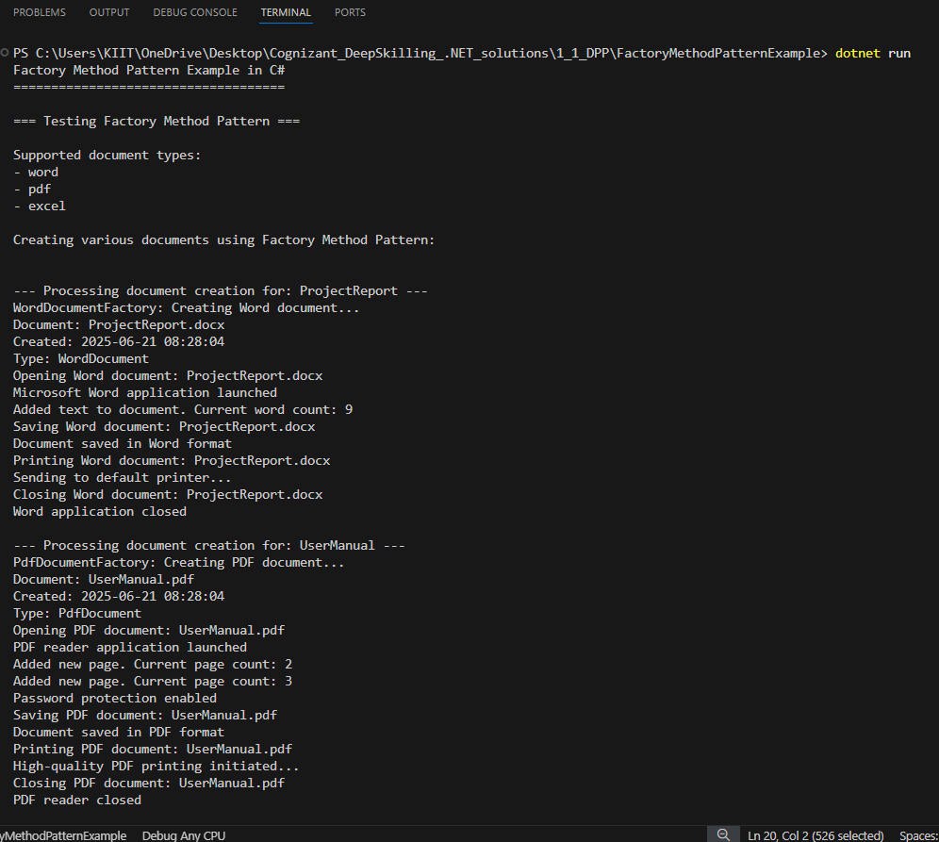**OUTPUT :**



